**Placement** [**https://citria.org/placements**](https://citria.org/placements)

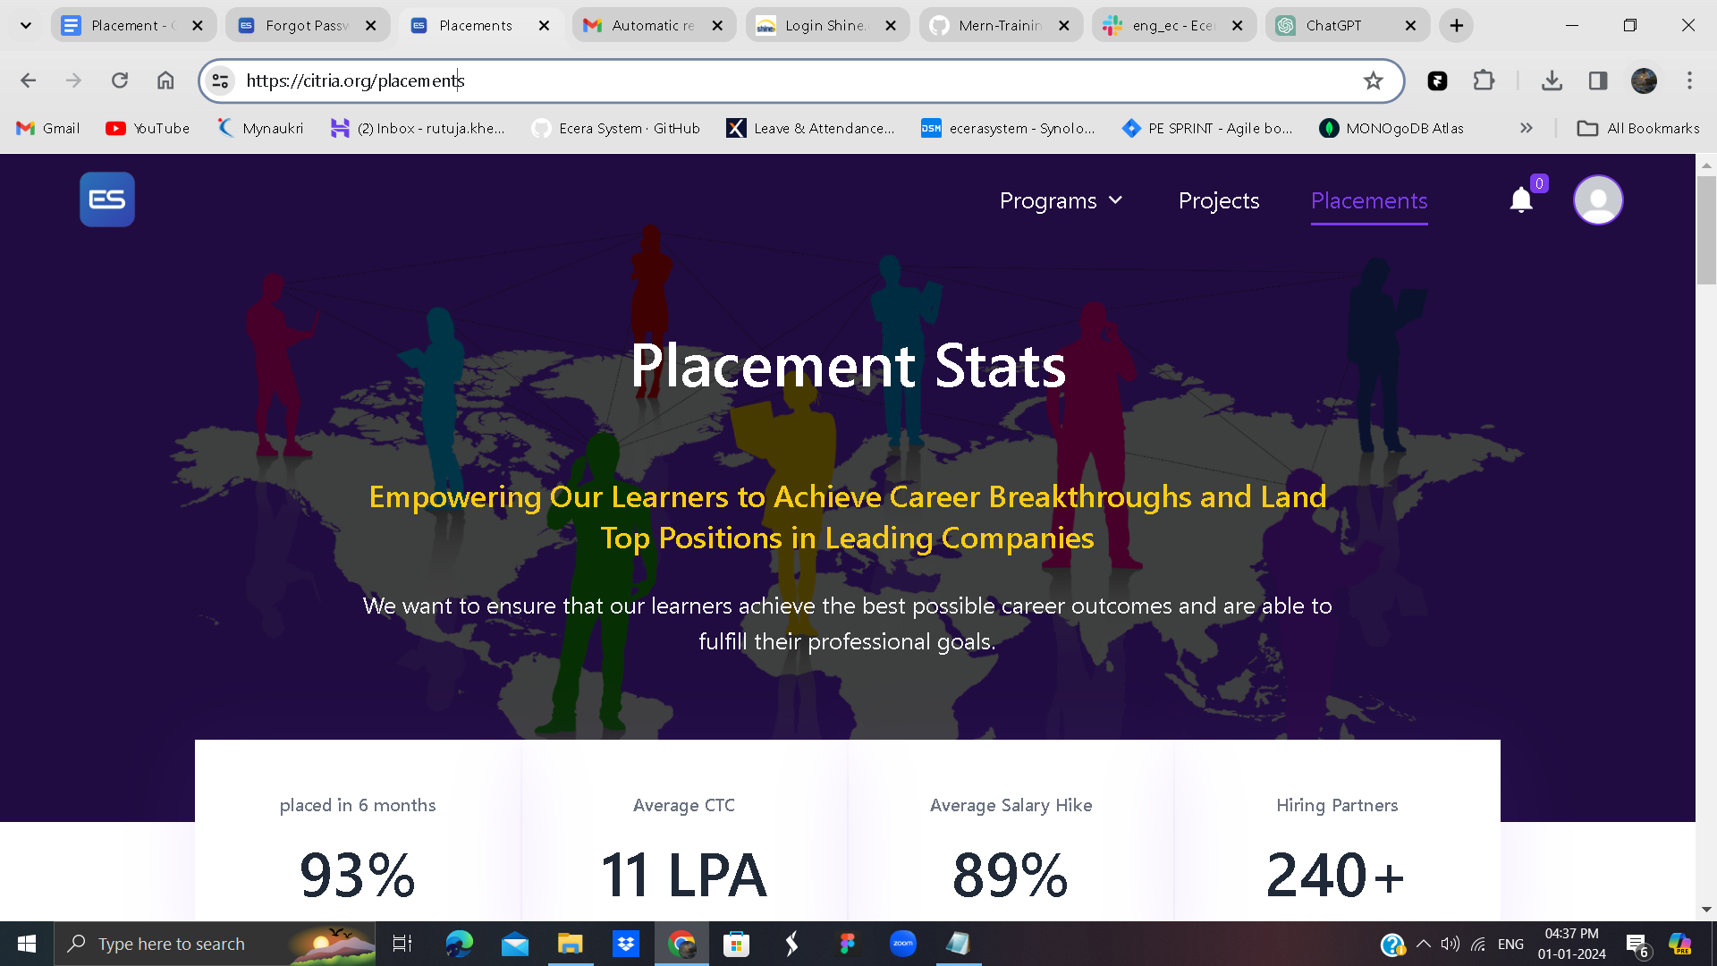

This code is a React component named Placements. Let's break down the code and explain its different parts:

Here, the component imports various modules and components from the React library, external libraries (react-slick for a carousel, axios for making HTTP requests), and local files (Header, PageTitle, Footer), as well as some icons (BsArrowLeft, BsArrowRight).

Component JSX Structure

The component's JSX structure is divided into different sections, each representing a part of a webpage:

Placement Stats Section: Displays placement statistics with a background image.

Quick Stats Section: Displays quick statistics such as placement rate, average CTC, salary hike, and hiring partners.

Top Companies Section: Shows logos of top companies and hyper-growth startups hiring from the program.

Learner Backgrounds Section: Illustrates the distribution of learners from different background.



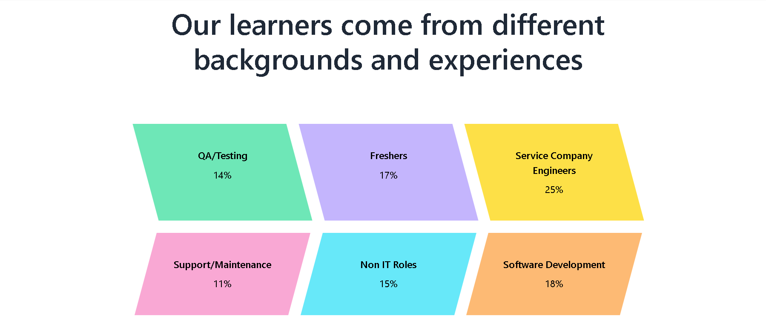

Conclusion Section: Encourages users to proceed with professional work experience to grab their dream job.

Footer: Includes a shared footer component.

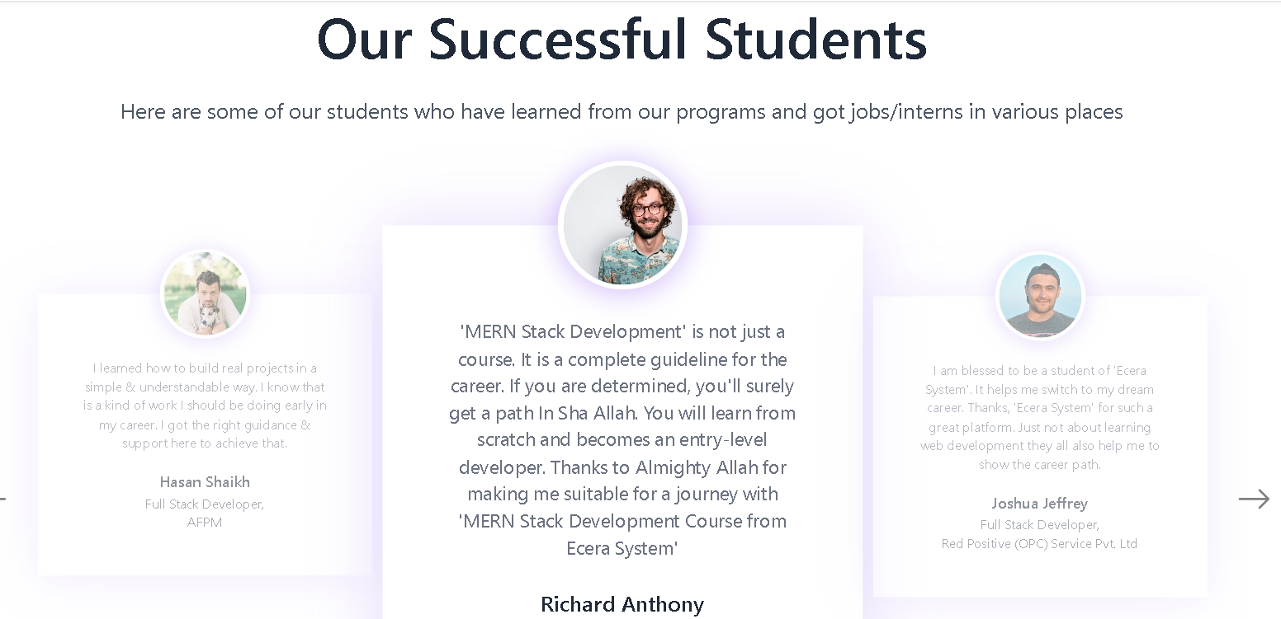

Successful Students Section: Displays a carousel of reviews from successful students who have found jobs/internships.